

**North South University**

**Course Name: CSE 215**

**Project Name: Travel Management System**

**Submitted by –**

**Name:**

**1.K.M.H.Mubin [162 1802 042]**

**2.MD Fuadul Islam [1631355042]**

**3.Abu Salah Akash [1611109042]**

Description:

Travel Management system is a powerful software which is based on Java. This program have so many function. We are use Java Fx for its UI.UI give the program a easy interface which will help anyone to understand. This program can be used by the office only. The officer manager can take input the customer information and the details of travel. In this program there are many option which are down below :

1. Customer Information
2. Travel Information
3. Hotel Booking
4. Ticket Booking
5. Customer Receipt

**1.Customer Information :** In this option, officer take input the customer name, Date of Birth, Address, Gender, Nationality, Contact Number, Email and most important thing for a traveler passport id. It will help a person to find about him easily.

**2.Travel Information :** It will show the customer departure point and his destination point with packages like ( 7 days,5 days)etc .

**3.Hotel Booking:** Show the best hotel available .So that, customer can travel without any worry on booking hotel.

**4.Ticket Booking :** Customer can book the ticket with return ticket. And what type of ticket a customer want. For example, we have option like Standard, First Class, and Economy class.

**5.Customer Receipt :** It will give the customer a printable receipt and print all the information about the traveling and show the total cost with tax. Every Customer have unique id on the receipt.

Beside there are some other some function like calculate the tax , total price. This program is easy to use for anyone and also have a eyecatching looking interface.

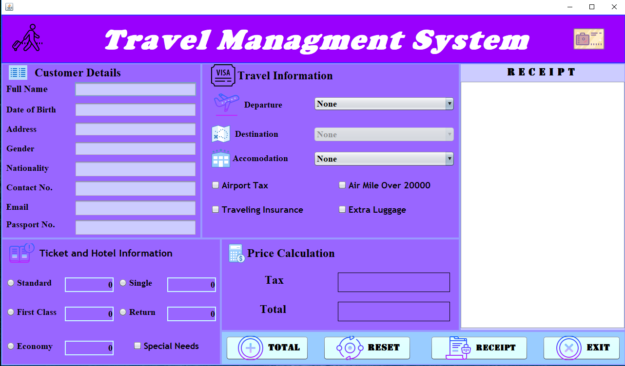

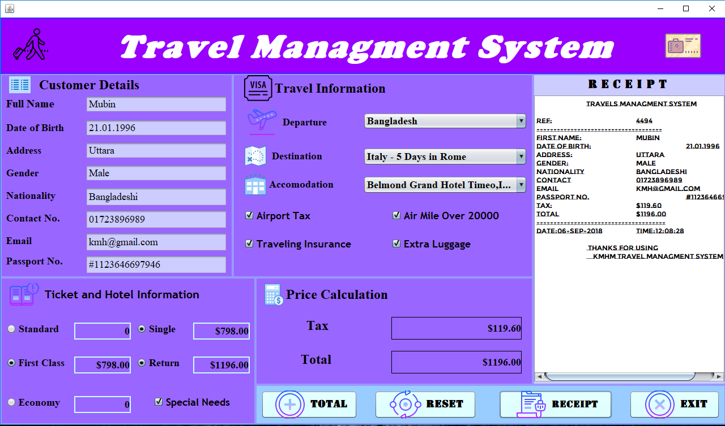

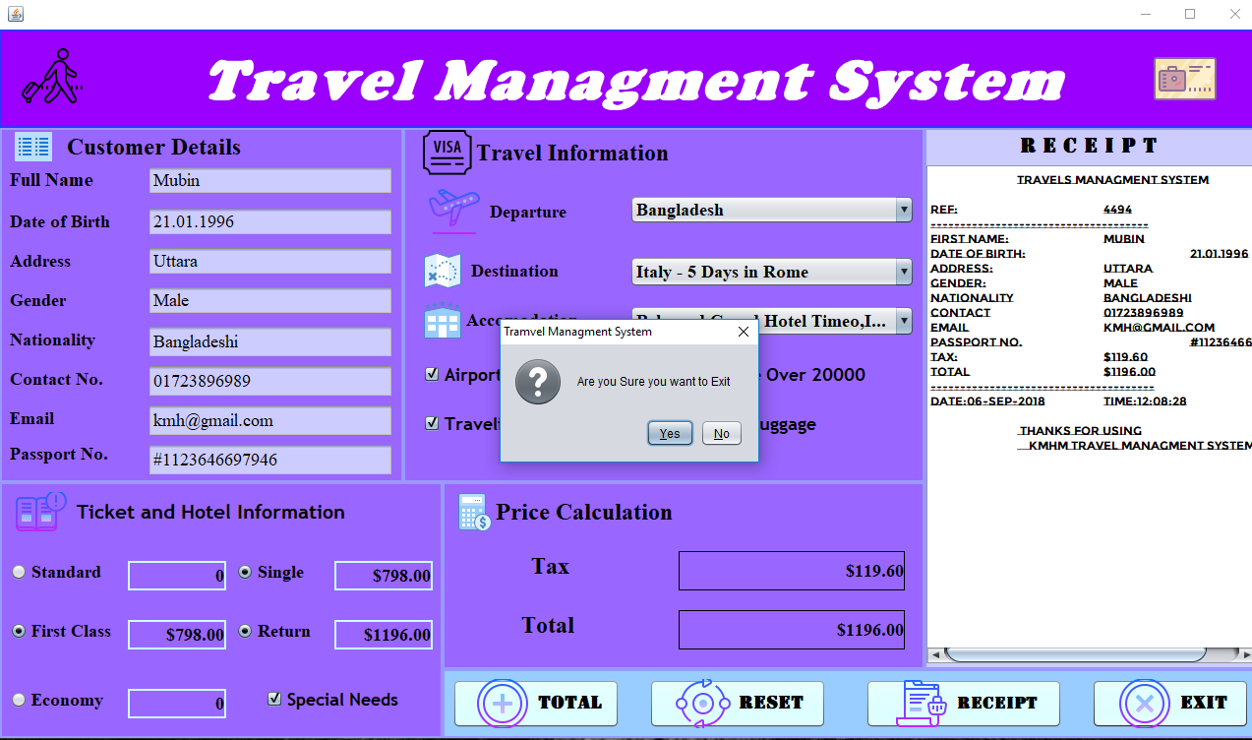

**UML Diagram Of Travel Management system:**

|  |
| --- |
| **TravelInterface extends javax.swing.JFrame** |
| * **Customer Details** * **Travel Information** * **Ticket and Hotel Information** * **Price calculation** * **Receipt** |

|  |
| --- |
| **Javax.Swing.JFrame** |
| * **Panal** * **Label** * **Button** * **Radio Check Box** * **Check Box** * **Text Field** * **Text Area** * **Exit Button** |

|  |
| --- |
| **+cCostTax();** |
| **+mcTax(double)**  **+cFindTax(double cAmount)** |

|  |
| --- |
| **+cFlight()** |
| **+ destinationPrice:(double)** |

|  |
| --- |
| **+ cquit()** |
| * **JFrame frame**   **+ quit(JOptionPane)** |

**Contribution:**